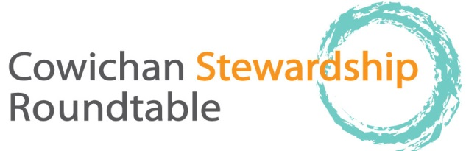

thursday, September 17, 2015, 9-12 AM.
Old Freshwater Ecocentre, Freshwater Fisheries Society, 1080 Wharncliffe Rd, 9:00–12:00
Please allow enough room in parking lot for Trout Hatchery vehicles and emergency vehicles, bring your coffee cup!

EVERYONE WELCOME
9:00 welcome, acknowledgement of meeting is on Cowichan Tribes territory, regrets, agenda changes, Attendance list to be circulated
Approval of Minutes (thank you Meg Loop!)
9:10 Round the Table: BRIEF updates as to projects, activities since last meeting
10:20 Break (10 min)

10:30: Business arising from last minutes.
- Conversation re forestry
- Request to Nature Trust to discuss Estuary Management
10:40 Discussion on Koksilah River, the forgotten watershed: Presenters may include (subject to availability): Tim Kulchyski (Cowichan Tribes), Swarn Leung (Koksilah Watershed committee, HUB), Tom Rutherford (DFO), Brian Tutty, (retired biologist), Dave Lindsay (Timberwest), Ken Epps (Island Timberlands), Wayne Haddow (BC Agriculture), Alison Nicholson (area director and river resident), Cheri Ayers (biologist and river resident), Kate Miller (CVRD) and others.
11:50 discussion of topics for future meetings: Cowichan Lake update, climate change issues
12:00 sharp: conclusion of meeting
Future meetings: November: Tim Clermont from NCC talking on Somenos Wildlife Management Area
Andrew Martel of Canada Museum (Quebec) on fresh water mussels research sometime in New Year.
Our meetings are always the third Thursday of the month, with the possible exception of August. Until further notice meetings are at the old Freshwater Ecocentre.

